Procedure to follow to calculate the t value using the Excel template.
Remember that the first step is to calculate the descriptive statistics.
Second, conduct the F test to determine if the variances are equal or not.
- Open the t test worksheet which will look similar to Fig. 1 below (the worksheet will be in color).
Fig.1.—Worksheet for calculating the t test.
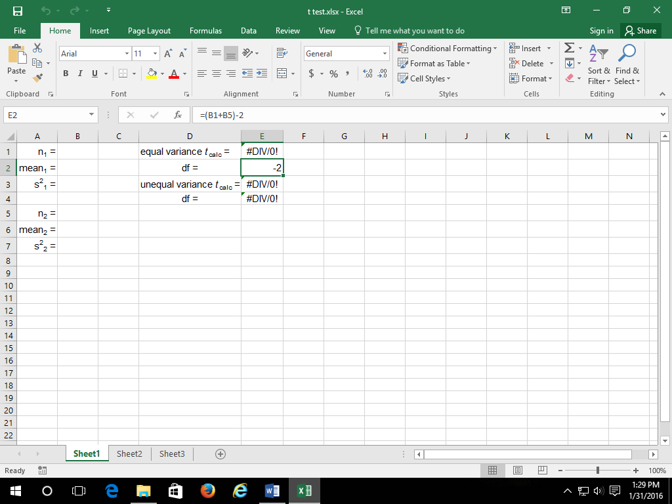
- Enter the number, mean, and variance for each of the samples in the appropriate cells (cells B1, B2, and B3 for the first sample; B5, B6, and B7 for the second sample) for each of the samples. Ensure that you use the variance NOT the standard deviation.
- The calculated t value (t_{calc}) and the appropriate degrees of freedom (df) for each test will be displayed (cells E1 and E2 for equal variances; cells E3 and E4 for unequal variances).

