Vegetation Analysis – Entering data into the worksheet.

To use the Vegetation Analysis template you must have Microsoft Excel version 2003 or later. All computers on campus have Microsoft Excel 2003 or later installed.

1. Open the Vegetation Analysis Worksheet. The worksheet will look similar to Fig.1 below:
Fig. 1—Vegetation analysis worksheet.
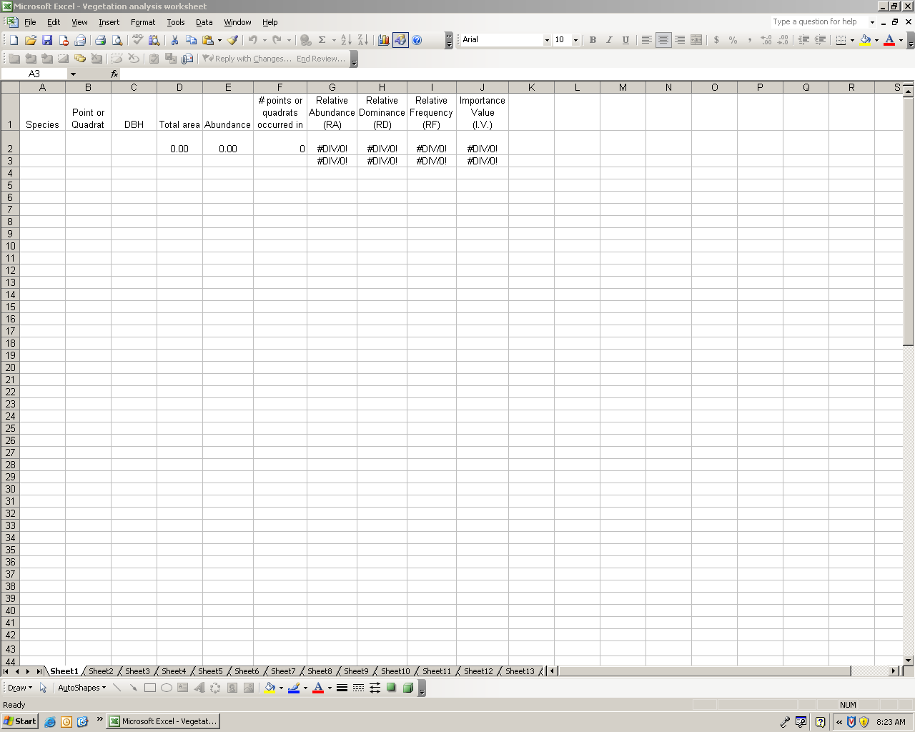
2. At the bottom of the worksheet is a series of sheet numbers (sheet 1, sheet 2, sheet 3, etc.). Click on sheet 1. Note: Each species must be entered on a separate worksheet. There are 100 sheets formatted with formulas, so you can enter up to 100 species and have the data automatically calculated.
3. Make sure that you begin in row 3, column A. From the canopy data form enter the first species’ code (first four letters of the genus and first four letters of the specific epithet) on your list, the point or quadrat that it occurred in, and the diameter breast height (DBH). Use a separate row for each individual tree (you can enter an unlimited number of individuals). Enter the information for the same species from all points or quadrats on the same sheet (see Fig. 2). All other information will be automatically calculated.
Fig. 2—Example entries for calculating vegetation analysis formulas.
Sheet 1
Sheet 2
4. Click on sheet 2 and enter the information for the second species.
5. Continue entering the information for each species on separate sheets (sheet 3 for the 3rd species, sheet 4 for the 4th species, and so on).
6. After you have entered all the information for all species, Relative Abundance, Relative Dominance, Relative Frequency, and Importance Values for each species will be displayed at the top of the sheet for the respective species. Row 3, columns G-J, are copies of the formula results that you can copy and paste into another document (to create a table for example). When pasting these cells, select past special then select the results box.
IMPORTANT NOTE – Even though numbers will appear in the designated cells after entering the information for each species, you must enter all information for all species before the calculations will be correct.

