Species Diversity – Entering data into the worksheet using Microsoft Excel.

To use the Species Diversity template you must have Microsoft Excel version 2003 or later. All the computers available in the library and the Physical Sciences computer lab (Room WA 181) have Excel 2003 or later installed.

1. Open the Species Diversity file. The worksheet will look like Fig.1 below:
Fig. 1 —Species Diversity worksheet for Microsoft Excel.
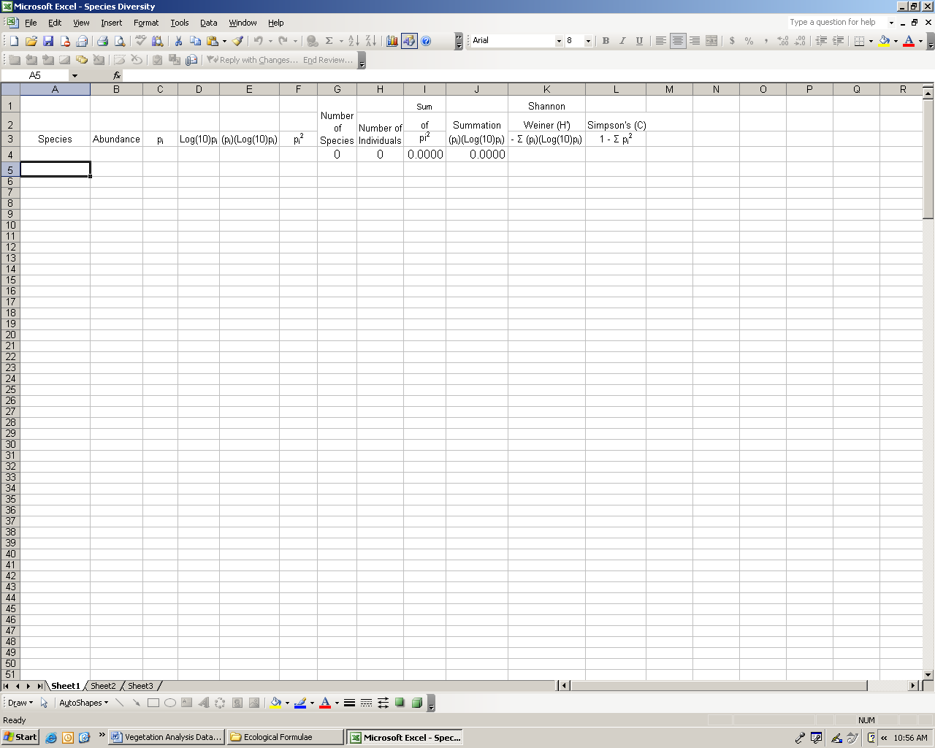
2. Make sure that you begin in row 4, column A. Enter the species name and abundance. Use a separate row for each species (you can enter an unlimited number of species). Continue to enter species names and abundances until all species in the sample have been entered. When all information has been entered, the number of species, the number of individuals, and both species diversity indices (Shannon-Weiner and Simpson’s) will be automatically calculated and displayed in row 4, columns G, H, K, and L, respectively (see Fig. 2).

Fig. 2 —Example entries for calculating species diversity formulas in Microsoft Excel.
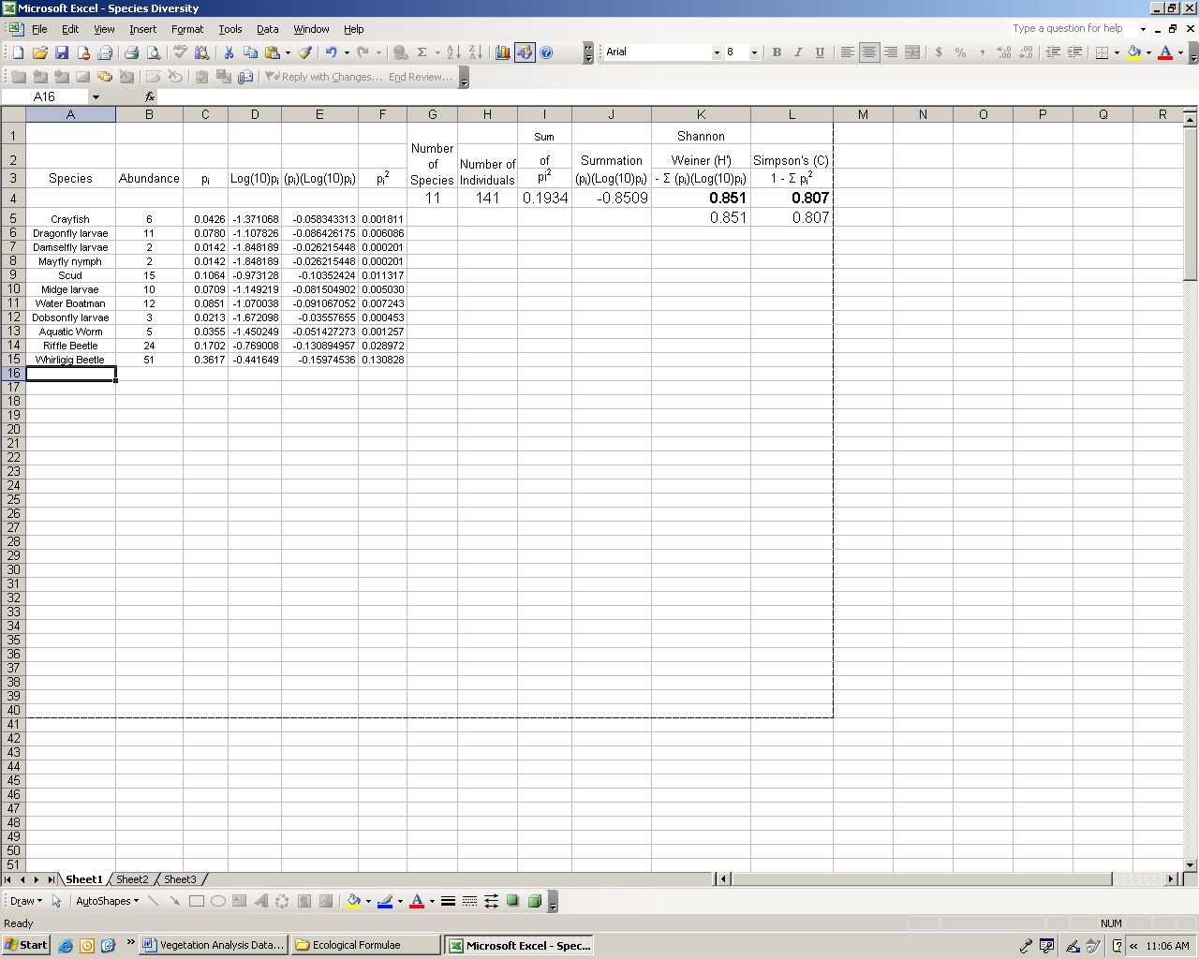
3. Record the number of species, the number of individuals, and both species diversity indices (Shannon-Weiner and Simpson’s) in Table 2 for the quadrat sampling and Table 4 for the Dredge sampling. Clear the species names and abundances. Repeat the procedure for each sample until all samples have been recorded.
4. To calculate the total species diversity of a community follow the same procedure as above using the totals for the community.
Row 5, columns K and L are copies of the formula results that you can copy and paste into another document (to create a table for example). When pasting these cells, select paste special then check the results box.
IMPORTANT NOTE – Even though numbers will appear in the designated cells after entering the information for each species, you must enter all information for all species before the calculations will be correct.

