Population Size Estimates – Entering Data into the spreadsheet.
To use the Population Estimate template you must have Microsoft Excel version 2003 or later. All the computers available in the library or the Physical Sciences Computer Lab (Room WA 181) have Excel 2003 or later installed.

1. Open the Population Estimate file. The worksheet will look similar to Fig.1 below:
Fig. 1 —Population Estimate worksheet for Microsoft Excel.
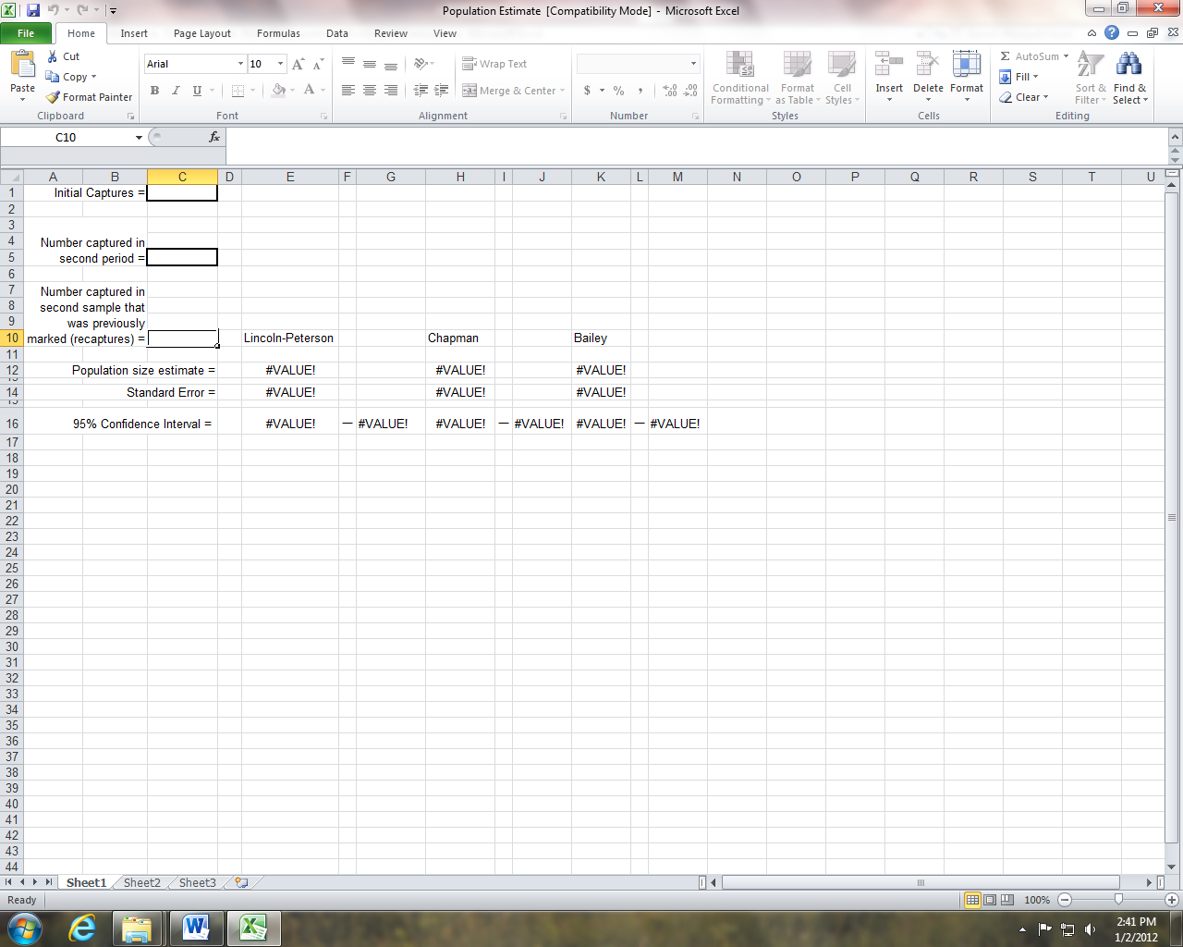

2. Make sure that you begin in row 1, column c. Enter the number of individuals in the initial sample. Move to row 5, column c and enter the number captured during the second capture period. Move to row 10, column c and enter the number the number of individuals captured during the second capture period that were previously marked during the first capture period. When all information has been entered, the Lincoln Peterson Population Size Estimate, the standard error, and the 95% Confidence Interval will be displayed in rows 12, 14, and 16 respectively. Two other estimates, the Bailey Modification and Chapman modification (both are for small sample sizes) will also be displayed. (see Fig. 2).

Fig. 2 —Example entries for population size estimates.
