Life Table Analysis – Entering data into the worksheet.

To use the Life Table Analysis template you must have Microsoft Excel version 2003 or later. All computers on campus have Microsoft Excel 2003 or later installed.

1. Open the appropriate Life Tables Worksheet (Age at Death or Cohort Size); your instructor will inform you of which one to use. The worksheet will look similar to Fig.1 (Age at Death) below (Note that both the Age at Death and Cohort Size appear identical but different data are entered into each one):
Fig. 1—Age at Death worksheet.
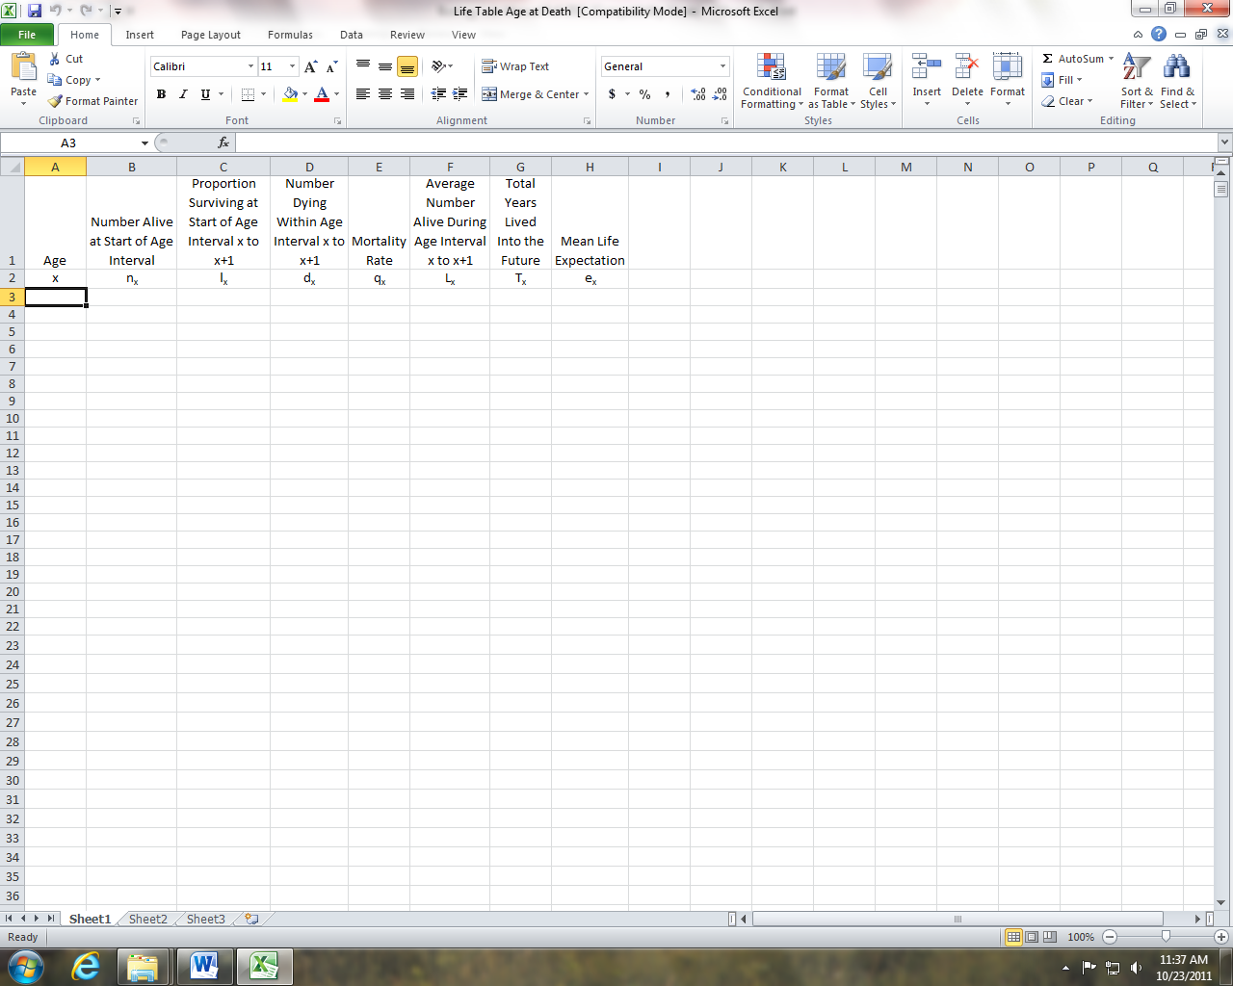

Fig. 2—Cohort Size worksheet.
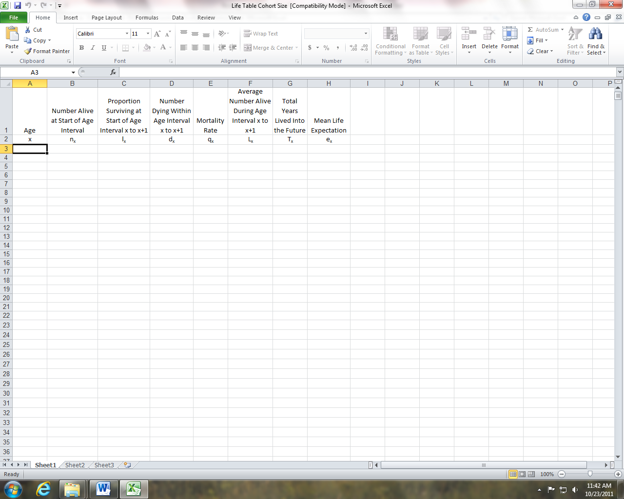
2. Make sure that you begin in row 3, column A. Enter the age range for each cohort. You can enter up to 50 age groups in either worksheet. Enter the Number Dying Within Age interval x to x+1 (d_{x}) for the Age at Death Worksheet or the Number Alive at Start of Age Interval (n_{x}) for the Cohort Size worksheet (see example entries in Fig. 3; and Fig. 4). All other information will be automatically calculated.
Fig. 3.—Example entries for the Number Dying Within Age interval x to x+1 (d_{x}) for the Age at Death Worksheet.
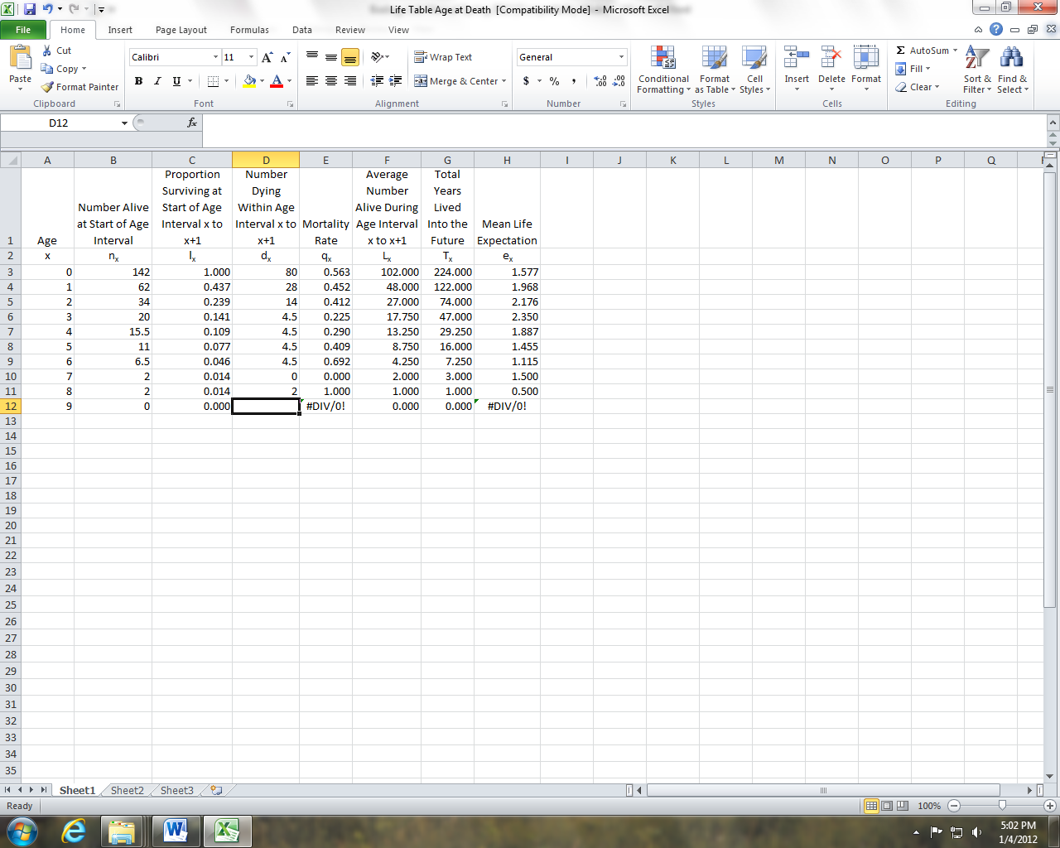

Fig. 4.—Example entries for the Number Alive at Start of Age Interval (n_{x}) for the Cohort Size Worksheet.
