Hilsenhoff Family Level Biotic Index (HFLBI) – Entering Data into the spreadsheet.

To use the HFLBI template you must have Microsoft Excel version 2003 or later. All the computers available in the library or the Physical Sciences Computer Lab (Room WA 181) have Excel 2003 or later installed.

1. Open the Hilsenhoff Biotic Index file. The worksheet will look similar to Fig.1 below:

Fig. 1 —Hilsenhoff Family Level Biotic Index worksheet for Microsoft Excel.

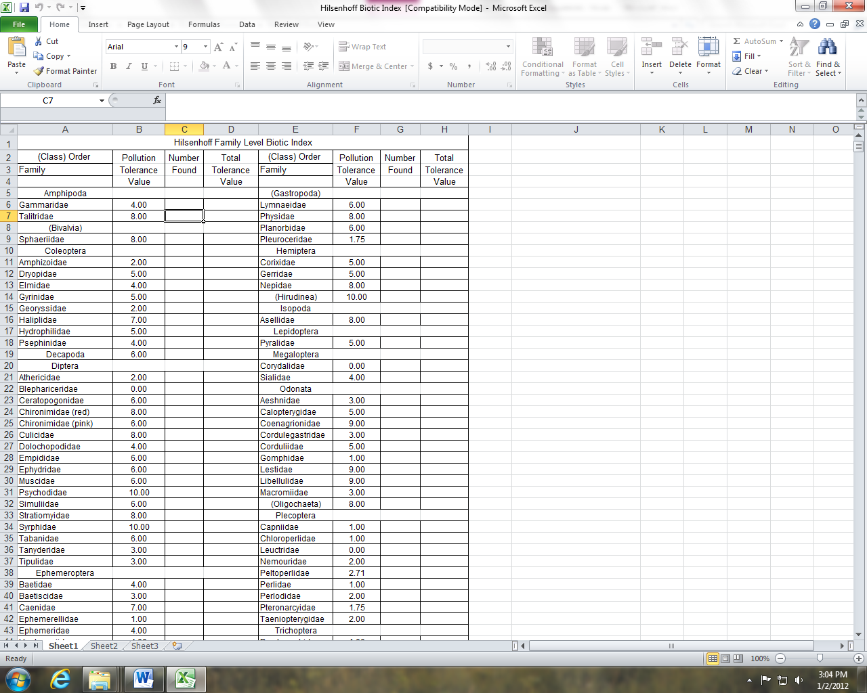

2. Find the family name of the first family on the worksheet and enter the abundance in the **Number Found** column. Repeat this procedure for all families that you collected. When all family abundances have been entered, the HFLBI will be displayed in Column C, Rows 54 and 55 (the two cells are merged so there will be only one number (see Fig. 2)).

**IMPORTANT NOTE** – Even though numbers will appear in the designated cells after entering the information for each family, **you must enter all information for all families before the calculations will be correct**.

Fig. 2 —Example entries for the Hilsenhoff Family Level Biotic Index.

